Part 1 – Mandatory Information

The information identified and captured in Part 1 of the Overlander Ski Club Board of Directors Application, MUST be completed in its entirety. Failure to complete this section of the application will result in an immediate disqualification of your application.
This form must be completed and provided to: info@overlanderskiclub.com no later than 23:59 pm PST March 25th 2024

Name (Please print): ______Luc Guilherme __________________

Desired board position:

President |  | Membership Administrator
Vice – President |  | Jr. Development Coordinator
Secretary |  | Volunteer Coordinator
Treasurer |  | Snowshoe Sport Coordinator
Publicity Director |  | Director Member at Large (6) | X
Ways & Means Director

Per the Societies Act of BC Part 5 – Management Division1, Section 44. Please circle your response.
- Are you 18 years of age or older? Yes / No
- Have you in any court in Canada or elsewhere been found or elsewhere, to be incapable of managing the individual's own affairs, unless a court, in Canada or elsewhere, subsequently finds otherwise? Yes / No
- Have you an undischarged bankruptcy? Yes / No
- Have you been convicted in or out of British Columbia of an offence in connection with the promotion, formation or management of a corporation or unincorporated entity, or of an offence involving fraud?
Yes / No

By signing this application, you are confirming that the responses provided to questions 1-4 are truthful.

Applicants Signature: ___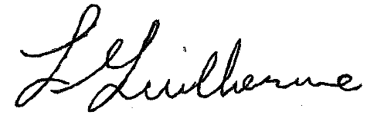________________________

Part 2 – Tell Us about Yourself

Bio – (100 word or less)
I have been involved with the ski club for over 30 years and have committed a lot of volunteer time to: equipment repair, tracksetting, trials committee, race timing, event organizing and as a director. I enjoy the ski community and still enjoy a good classic ski.

Why do you want to be on the board? (75 words or less)
I would like to continue to guide our ski club in providing an open, welcoming venue and develop future ski programs for our community.

What Skills and Experience do you bring to the board? (75 words or less)
I have 10 years experience as a mechanic, 10 + years in construction, 15 years in IT and over 15 years volunteering as a XC ski race official.

