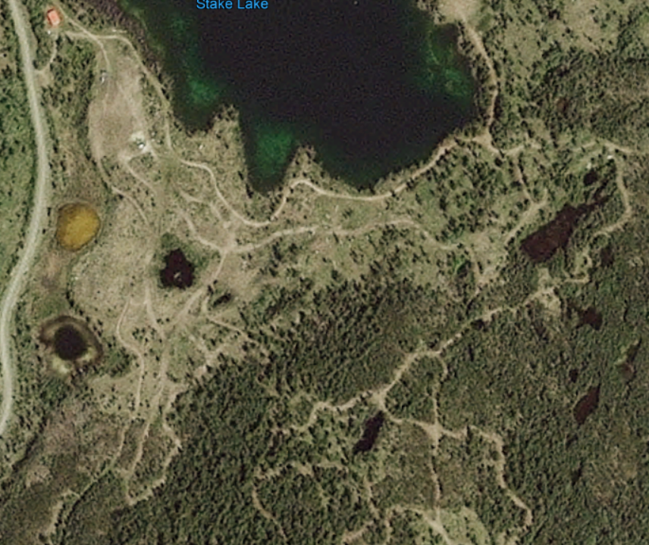

Start Waxing area
Finish Machine Shop/Athletes Village race area
Ski playground

