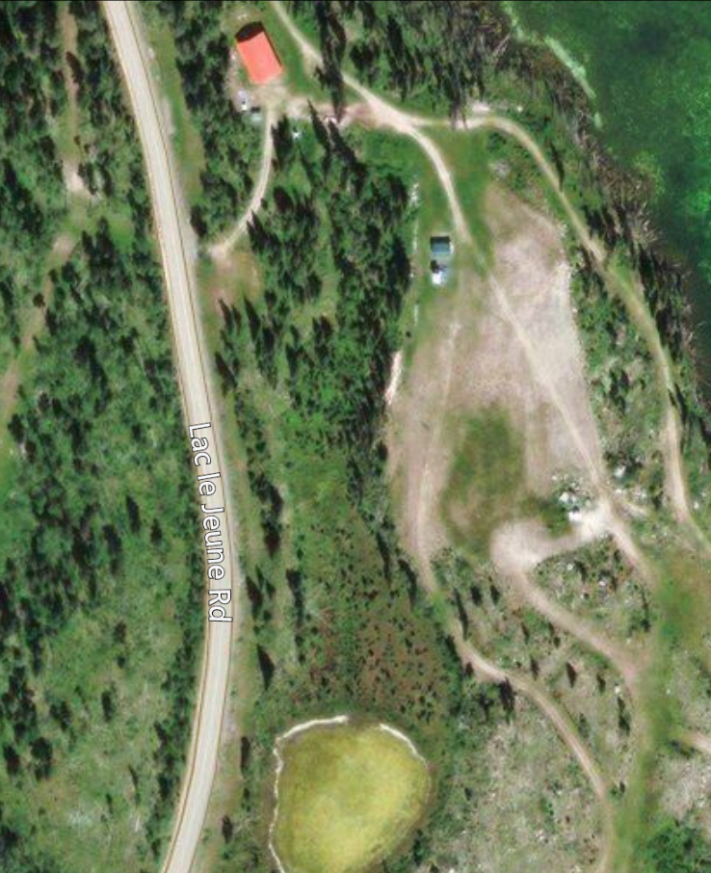

Start Waxing area
Finish Machine Shop/Athletes Village race area

