Overlander Ski Club Trails Report 2023-2024

Our 33rd year of operations brought us new challenges and new growth. Despite the club being ready to go for a November opening like last season, Mother Nature did not gift us with any snow until January. One of our latest opening dates in our history.

In accordance with our short season, our trail numbers were quite low compared to previous season. We did however see more ski days and user numbers than the 2014/2015 season, which was a season very comparable in weather. We saw 11351 users this season over 63 days of being open.

After a tense summer of wondering if we would lose the trails to fire, we were ready to get back to business as usual bigger and better than ever. With a Loppet, Masters Clinic, Waxing Clinic and many new events planned, the club was full of enthusiasm for making this season the best yet. Little did we know, we would need to channel that enthusiasm into being creative, adaptive, and expanding what we thought was possible for our club in the face of challenges.

The fall work consisted of New Gold generously donating time and machine work into upgrading the dog trails so that the new snowcat could be used. The club also rented a large-scale brush cutter and Stew, Kelly and Chris B put time and effort into carefully manicuring and cutting the trails down for optimal grooming. Our usual fantastic crew of summer and fall volunteers took the time to rock pick and trim their designated trails to ensure they were in the best shape possible. Tom and Tim put up every single new trail map and sign in the system while Roy T and Ron S helped prune and reflag the snowshoe trails. Chris J and Peter V diligently serviced snowcats and snowmobiles, putting in many long tedious days in anticipation for the season.

And then we had to wait….and wait. When the smallest amount of snow finally came, our groomers did not hesitate to roll and pack whatever we had to make it skiable. Never has a 5cm base skied so well. Our grooming and operations team had to continually evaluate and adapt this season. From new pieces of unconventional homemade grooming equipment, to shovelling snow off the lake to patch rough areas of trail. The attitude remained; overcome and adapt- to have the best ski season possible. There were many stunning ski days, even in weather and conditions that shocked us all that the skiing could be so good.

Our club had to sadly cancel our Loppet, but we did see major success in our Long Ski Day in partnership with Whitehorse Nordic, our first ever Masters Clinic, and our Waxing Clinic days. Behind the scenes these challenges and successes have set the building blocks for even more events, programs and races like these to take place in future seasons. 950 children from the local school districts went through the Ski Skool program this year. An astounding number given challenging conditions, and a testament to the determination and creativity from our amazing Ski Skool Staff- Shelley, Nome, Deidre and Delia, and our fantastic groomers who take great pride in supporting our ski skool program.

We are thankful for our exceptional Staff, led by our GM Chelsea, our assistant manager Kate and their wonderful team of Michael, JD, Brett, Tracy, Avi and Maya.

We are also grateful for our dedicated Trails Committee who put in countless hours behind the scenes to keep buildings, trails and various equipment maintained and working. Tim Cole, Alan Vyse, Chris Jones, Stew Stankiewics, Luc Guilherme, Thomas Bennett and Klaus Mey.

Through many moments that seemed bleak and disappointing, our team rose to challenges with positivity, ingenuity and commitment to the best skiing possible for everyone. Our club is incredibly proud of what was made possible in the toughest year on record, and all the silver linings and tremendous growth in knowledge and experience this brought the club. We are very grateful for the continuing support of our amazing members, who without your enthusiasm for this sport and our community, none of this would be possible or worthwhile.

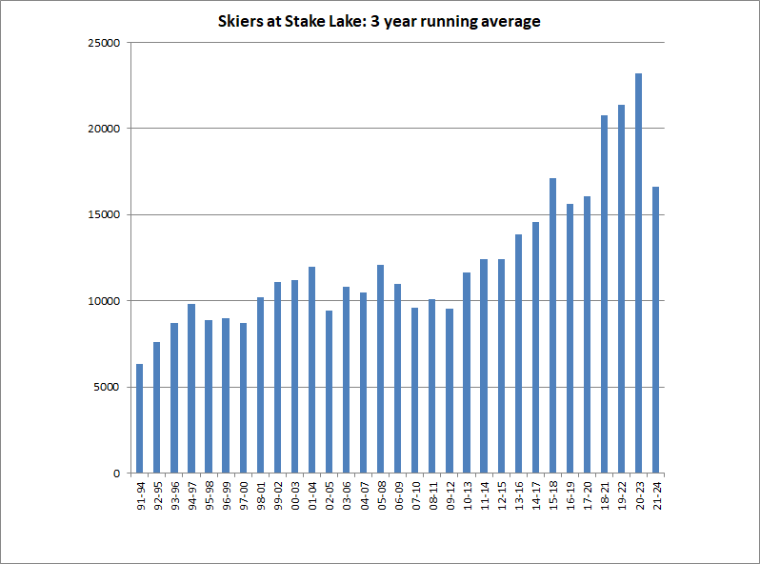

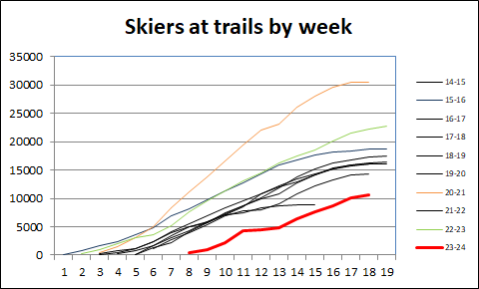

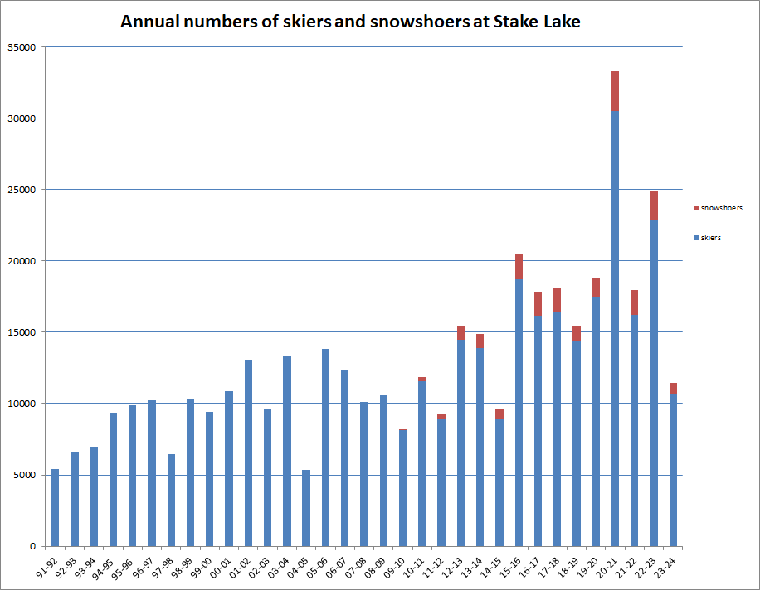

This report was prepared by GM Chelsea Francis and Trails Committee members Alan Vyse and Tim Cole.

Submitted March 25th 2024

